Geospatial Analysis: 1st lesson – Your First Map

In this micro-course, you will learn about different methods to wrangle and visualize geospatial data, or data with a geographic location.

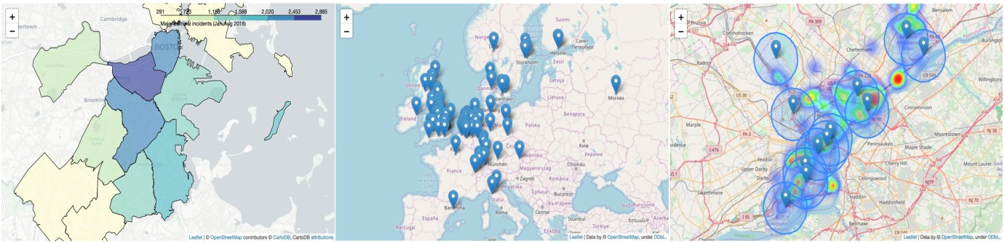

Along the way, you will offer solutions to real-world problems like:

* Where should a global non-profit expand its reach in remote areas of the Philippines?
* How do purple martins, a threatened bird species, travel between North and South America? Are the birds travelling to conservation areas?
* Which areas of Japan could potentially benefit from extra earthquake reinforcement?
* Which Starbucks stores in California are strong candidates for the next Starbucks Reserve Roastery location?
* Does New York City have sufficient hospitals to respond to motor vehicle collisions? Which areas of the city have gaps in coverage?

You will also visualize crime in the city of Boston, examine health facilities in Ghana, explore top universities in Europe, and track releases of toxic chemicals in the United States.

In this first tutorial, we will quickly cover the pre-requisites that you'll need to complete this micro-course. And, if you'd like to review more deeply, we recommend the pandas micro-course. We will also get started with visualizing our first geospatial dataset!

Reading data:

The first step is to read in some geospatial data. To do this, we'll use the GeoPandas library.

import geopandas as gpd

/opt/conda/lib/python3.7/site-packages/geopandas/_compat.py:115: UserWarning: The Shapely GEOS version (3.9.1-CAPI-1.14.2) is incompatible with the GEOS version PyGEOS was compiled with (3.10.4-CAPI-1.16.2). Conversions between both will be slow.

shapely_geos_version, geos_capi_version_string

There are many, many different geospatial file formats, such as shapefile, GeoJSON, KML, and GPKG. We won't discuss their differences in this micro-course, but it is important to mention that:

* shapefile is the most common file type that you will encounter.
* All of these file types can be quickly loaded with the gpd.read_file() function.

The next code cell loads a shapefile containing information about forests, wilderness areas, and other lands under the care of the Department of Environmental Conservation in the state of New York.

*# Read in the data*

full_data = gpd.read_file("../input/geospatial-learn-course-data/DEC_lands/DEC_lands/DEC_lands.shp")

*# View the first five rows of the data*

full_data.head()

OBJECTID CATEGORY UNIT FACILITY CLASS UMP DESCRIPTIO REGION COUNTY URL SOURCE UPDATE_ OFFICE ACRES LANDS_UID GREENCERT SHAPE_AREA SHAPE_LEN geometry

0 1 FOR PRES DET PAR CFP HANCOCK FP DETACHED PARCEL WILD FOREST None DELAWARE COUNTY DETACHED PARCEL 4 DELAWARE http://www.dec.ny.gov/ DELAWARE RPP 5/12 STAMFORD 738.620192 103 N 2.990365e+06 7927.662385 POLYGON ((486093.245 4635308.586, 486787.235 4...

1 2 FOR PRES DET PAR CFP HANCOCK FP DETACHED PARCEL WILD FOREST None DELAWARE COUNTY DETACHED PARCEL 4 DELAWARE http://www.dec.ny.gov/ DELAWARE RPP 5/12 STAMFORD 282.553140 1218 N 1.143940e+06 4776.375600 POLYGON ((491931.514 4637416.256, 491305.424 4...

2 3 FOR PRES DET PAR CFP HANCOCK FP DETACHED PARCEL WILD FOREST None DELAWARE COUNTY DETACHED PARCEL 4 DELAWARE http://www.dec.ny.gov/ DELAWARE RPP 5/12 STAMFORD 234.291262 1780 N 9.485476e+05 5783.070364 POLYGON ((486000.287 4635834.453, 485007.550 4...

3 4 FOR PRES DET PAR CFP GREENE COUNTY FP DETACHED PARCEL WILD FOREST None None 4 GREENE http://www.dec.ny.gov/ GREENE RPP 5/12 STAMFORD 450.106464 2060 N 1.822293e+06 7021.644833 POLYGON ((541716.775 4675243.268, 541217.579 4...

4 6 FOREST PRESERVE AFP SARANAC LAKES WILD FOREST WILD FOREST SARANAC LAKES None 5 ESSEX http://www.dec.ny.gov/lands/22593.html DECRP, ESSEX RPP 12/96 RAY BROOK 69.702387 1517 N 2.821959e+05 2663.909932 POLYGON ((583896.043 4909643.187, 583891.200 4...

As you can see in the "CLASS" column, each of the first five rows corresponds to a different forest. For the rest of this tutorial, consider a scenario where you'd like to use this data to plan a weekend camping trip. Instead of relying on crowd-sourced reviews online, you decide to create your own map. This way, you can tailor the trip to your specific interests.

Prerequisites:

To view the first five rows of the data, we used the head() method. You may recall that this is also what we use to preview a Pandas DataFrame. In fact, every command that you can use with a DataFrame will work with the data! This is because the data was loaded into a (GeoPandas) GeoDataFrame object that has all of the capabilities of a (Pandas) DataFrame.

type(full_data)

geopandas.geodataframe.GeoDataFrame

For instance, if we don't plan to use all of the columns, we can select a subset of them.

data = full_data.loc[:, ["CLASS", "COUNTY", "geometry"]].copy()

We use the value_counts() method to see a list of different land types, along with how many times they appear in the dataset.

*# How many lands of each type are there?*

data.CLASS.value_counts()

WILD FOREST 965

INTENSIVE USE 108

PRIMITIVE 60

WILDERNESS 52

ADMINISTRATIVE 17

UNCLASSIFIED 7

HISTORIC 5

PRIMITIVE BICYCLE CORRIDOR 4

CANOE AREA 1

Name: CLASS, dtype: int64

You can also use loc (and iloc) and isin to select subsets of the data.

*# Select lands that fall under the "WILD FOREST" or "WILDERNESS" category*

wild_lands = data.loc[data.CLASS.isin(['WILD FOREST', 'WILDERNESS'])].copy()

wild_lands.head()

CLASS COUNTY geometry

0 WILD FOREST DELAWARE POLYGON ((486093.245 4635308.586, 486787.235 4...

1 WILD FOREST DELAWARE POLYGON ((491931.514 4637416.256, 491305.424 4...

2 WILD FOREST DELAWARE POLYGON ((486000.287 4635834.453, 485007.550 4...

3 WILD FOREST GREENE POLYGON ((541716.775 4675243.268, 541217.579 4...

4 WILD FOREST ESSEX POLYGON ((583896.043 4909643.187, 583891.200 4...

If you're not familiar with the commands above, you are encouraged to bookmark this page for reference, so you can look up the commands as needed. (Alternatively, you can take the pandas micro-course.) We'll use these commands throughout this micro-course to understand and filter data before creating maps.

Creating your first map:

We can quickly visualize the data with the plot() method.

wild_lands.plot()

<AxesSubplot:>

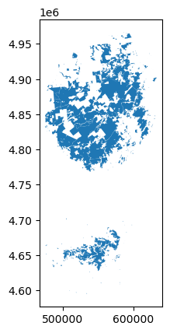

Every GeoDataFrame contains a special "geometry" column. It contains all of the geometric objects that are displayed when we call the plot() method.

*# View the first five entries in the "geometry" column*

wild_lands.geometry.head()

0 POLYGON ((486093.245 4635308.586, 486787.235 4...

1 POLYGON ((491931.514 4637416.256, 491305.424 4...

2 POLYGON ((486000.287 4635834.453, 485007.550 4...

3 POLYGON ((541716.775 4675243.268, 541217.579 4...

4 POLYGON ((583896.043 4909643.187, 583891.200 4...

Name: geometry, dtype: geometry

While this column can contain a variety of different datatypes, each entry will typically be a Point, LineString, or Polygon.



The "geometry" column in our dataset contains 2,983 different Polygon objects, each corresponding to a different shape in the plot above. In the code cell below, we create three more GeoDataFrames, containing campsite locations (Point), foot trails (LineString), and county boundaries (Polygon).

*# Campsites in New York state (Point)*

POI_data = gpd.read_file("../input/geospatial-learn-course-data/DEC_pointsinterest/DEC_pointsinterest/Decptsofinterest.shp")

campsites = POI_data.loc[POI_data.ASSET=='PRIMITIVE CAMPSITE'].copy()

*# Foot trails in New York state (LineString)*

roads_trails = gpd.read_file("../input/geospatial-learn-course-data/DEC_roadstrails/DEC_roadstrails/Decroadstrails.shp")

trails = roads_trails.loc[roads_trails.ASSET=='FOOT TRAIL'].copy()

*# County boundaries in New York state (Polygon)*

counties = gpd.read_file("../input/geospatial-learn-course-data/NY_county_boundaries/NY_county_boundaries/NY_county_boundaries.shp")

Next, we create a map from all four GeoDataFrames. The plot() method takes as (optional) input several parameters that can be used to customize the appearance. Most importantly, setting a value for ax ensures that all of the information is plotted on the same map.

*# Define a base map with county boundaries*

ax = counties.plot(figsize=(10,10), color='none', edgecolor='gainsboro', zorder=3)

*# Add wild lands, campsites, and foot trails to the base map*

wild_lands.plot(color='lightgreen', ax=ax)

campsites.plot(color='maroon', markersize=2, ax=ax)

trails.plot(color='black', markersize=1, ax=ax)

<AxesSubplot:>

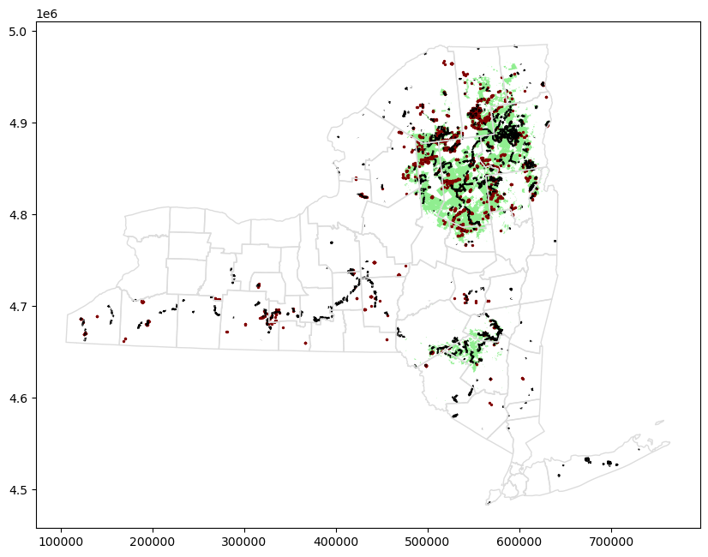

It looks like the northeastern part of the state would be a great option for a camping trip!